GROUP 9 Zen Garden  
Members: Carolina Acevedo and Michael Muir  
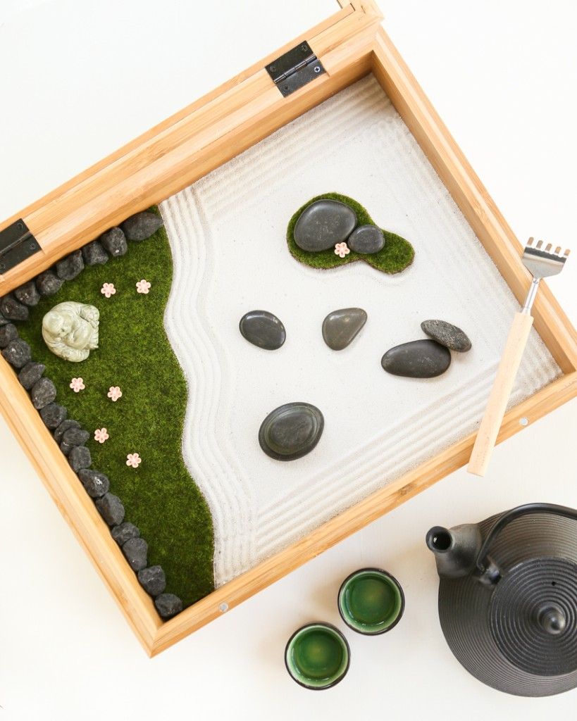So, what we have picked for our theme is a sand garden. this is something that people have on their desk to their hole back yard, it is a personal thing that you do to relax. No two sand gardens are the same, you move the sand. We think a relaxing theme would be nice to make right now during all that is going on in the world. We still need to refine the small details, but we have lots of the bigger ones down. We have our colors picked out 55524B Gray, 505921 Green, and F1F0EC sand color these are our main colors, but we are probably going to use different shades of gray. Our background will be the sand color we might add sand lines around text we haven’t talk about it yet. We will be finding some rocks that go with our color we have picked for gray and use them in the design we have not looked for rocks yet but we have our color so that will help. The green will be used for titles and other decorations on the page, maybe our nav bar but we are still working on that. We are one member short so we have somethings we are still working on but we are trying to make up for that fact and not let that slow us down.

Layout ideas

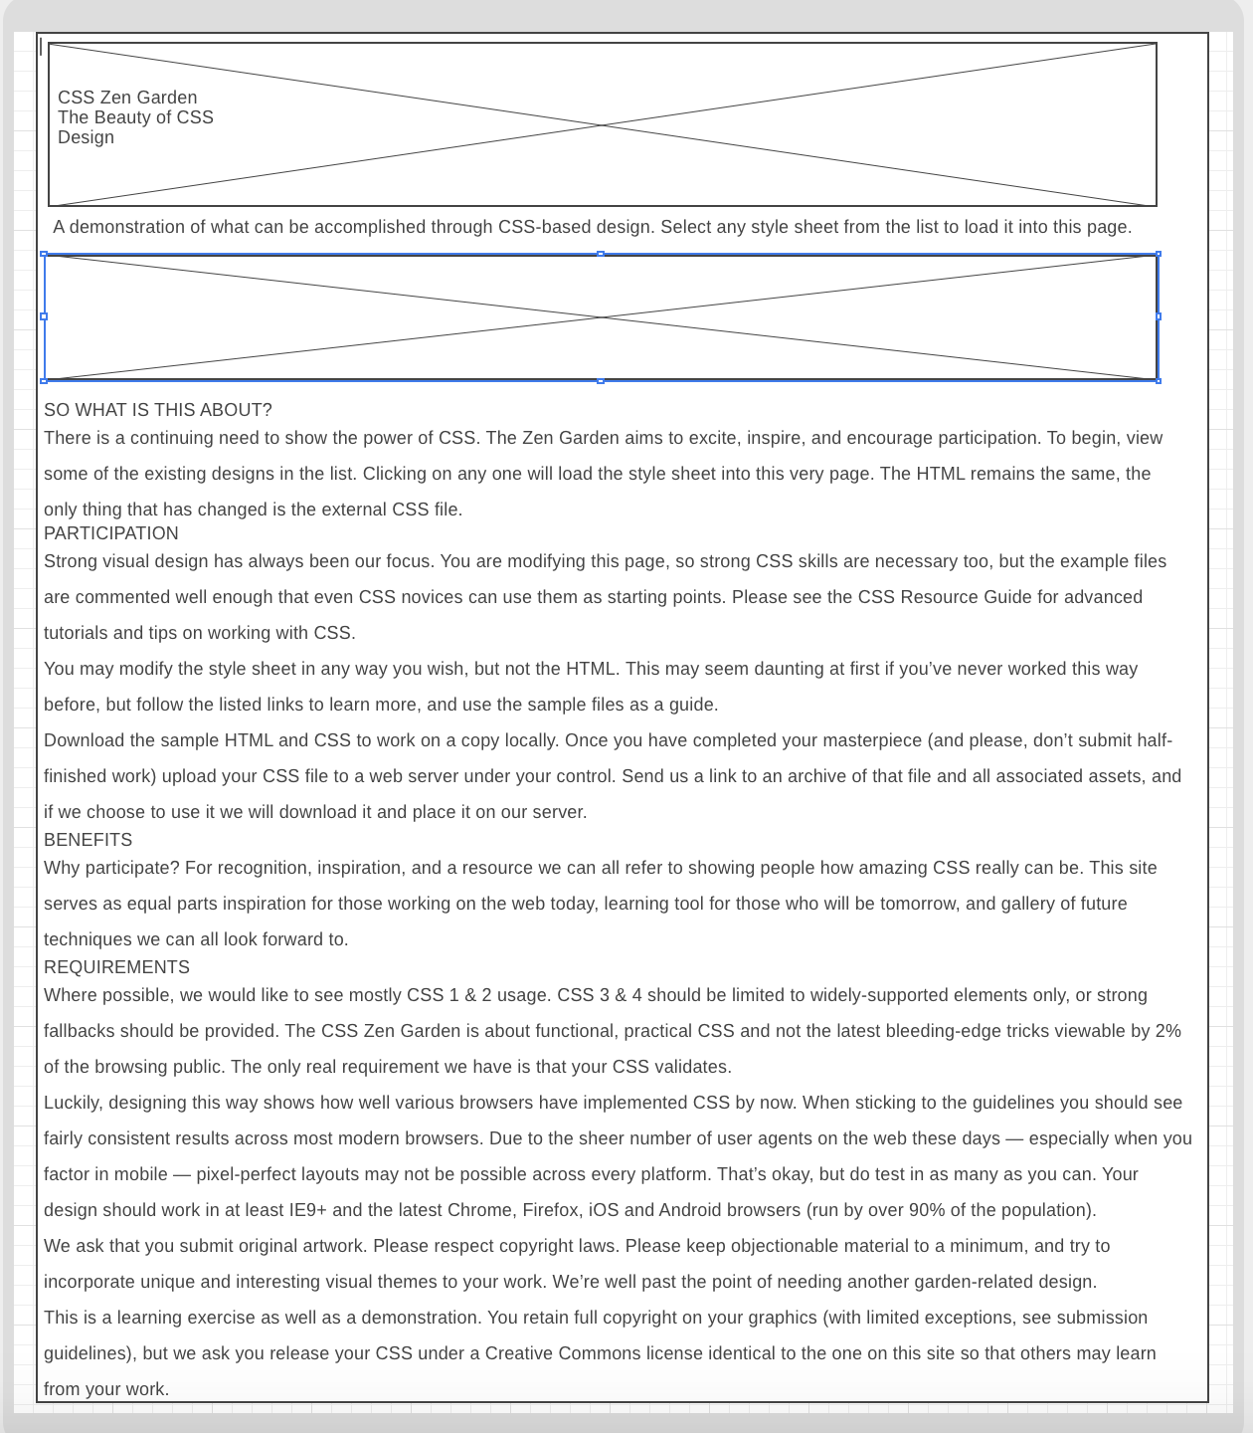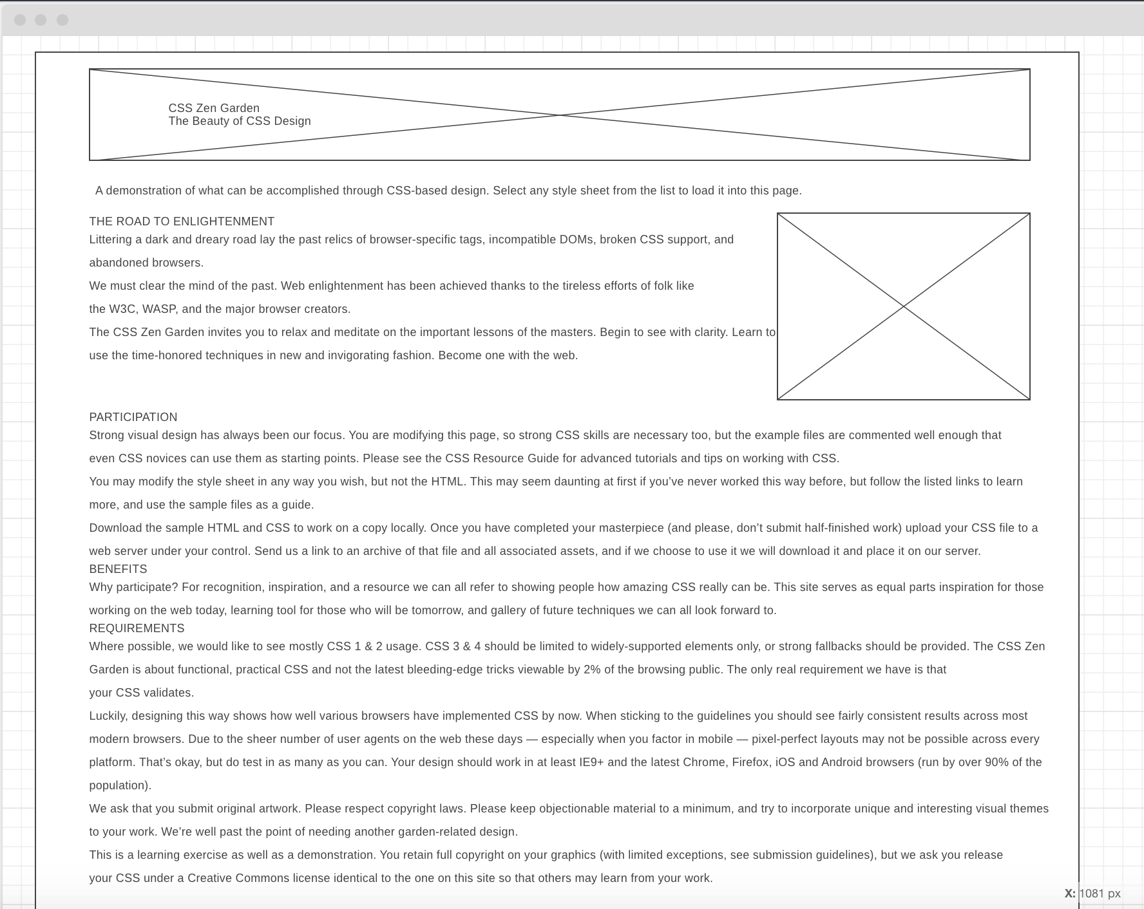

Mobile Desktop  
  
  
 